

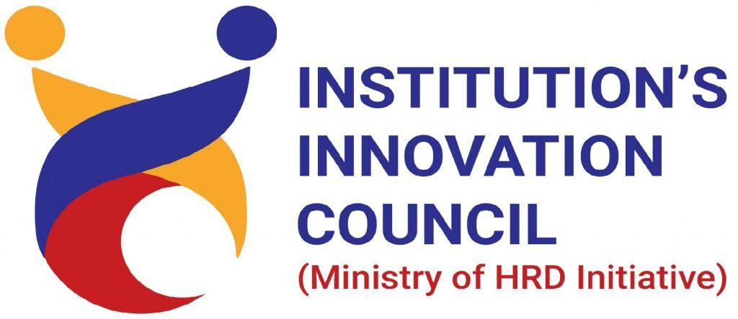

Certiﬁcate of Participation

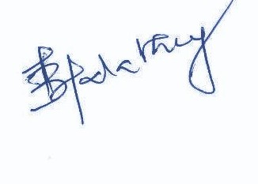This is to certify that THIYANESWARAN B, SONA COLLEGE OF TECHNOLOGY has successfully participated in one-week online FDP on “Effective and Instructive Research” from 4 May - 10 May,2020 organized by Department of Civil Engineering, Sona College of Technology, Salem.



Co-Ordinator HoD/Civil